(Q) What are the new tags added in HTML5?

A. The following tags(element) have been introduced in HTML 5-

|  |  |
| --- | --- |
| <header> | Represents a group of introductory or navigational aids. |
| <nav> | Represents a section of the document intended for navigation. |
| <article> | Represent a independent piece of content of a document, such as a blog entry or newspaper article. |
| <section> | Represents a generic document or application section. |
| <aside> | Represent a piece of content that is only slightly related to the rest of a page. |
| <footer> | Represent a footer for a section and can contain information about the author, copyright information, et cetera. |
| <time> | Represents a date and/or time. |
| <canvas> | This is used for rendering dynamic bitmap graphics on the fly, such as graphs of games. |
| <embed> | Defines external interactive content or plugin. |
| <meter> | Represent a measurement, such as disk usages. |
| <video> | Defines a video file. |
| <audio> | Defines a audio file. |
| <command> | Represents a command the user can invoke. |
| <keygen> | Represents controls for key pair generation. |
|  |  |

(Q) How to embed audio and video in a webpages?

A. The HTML 5<audio> and <video tags make it simple to add media to a website.

Audio input:

<!DOCTYPE html>

<html lang="en">

<head>

    <meta charset="UTF-8">

    <meta name="viewport" content="width=device-width, initial-scale=1.0">

    <title>Document</title>

</head>

<body>

    <div style="background-color:red;">

    <h1>Click to play</h1>

    <audio src="audio/Aashiqui Aa Gayi Ringtone(PagalWorld).mp3" controls></audio>

</body>

</html>

Audio Output:



Video Input:

<html lang="en">

<head>

    <meta charset="UTF-8">

    <meta name="viewport" content="width=device-width, initial-scale=1.0">

    <title>Document</title>

</head>

<body>

    <div style="background-color:red;">

    <h1>Click to play</h1>

    <video src="image/WhatsApp Video 2023-07-11 at 10.49.48 AM.mp4" controls></video>

</body>

</html>

Video Output:

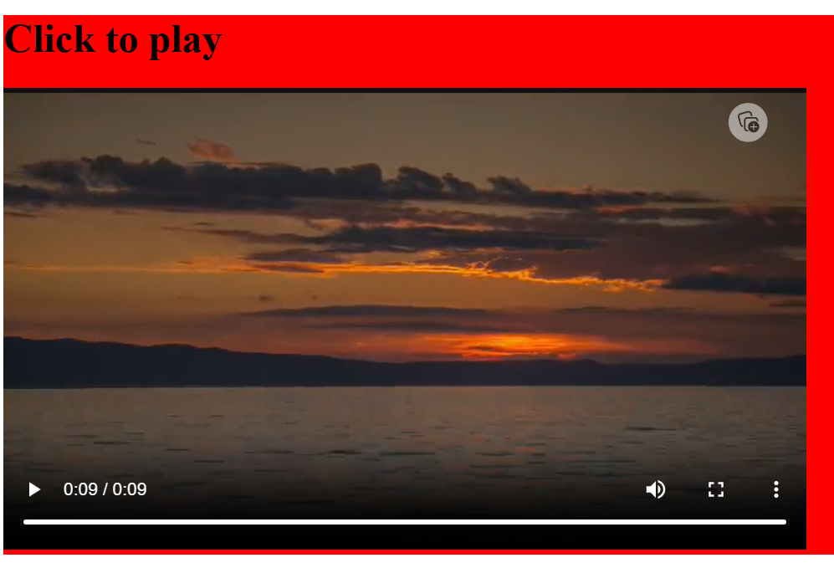

(Q) Sematic element in HTML 5?

A. A sematic element clearly describes its meaning to both the developer.

Example:

<form>,<table>,<article>.

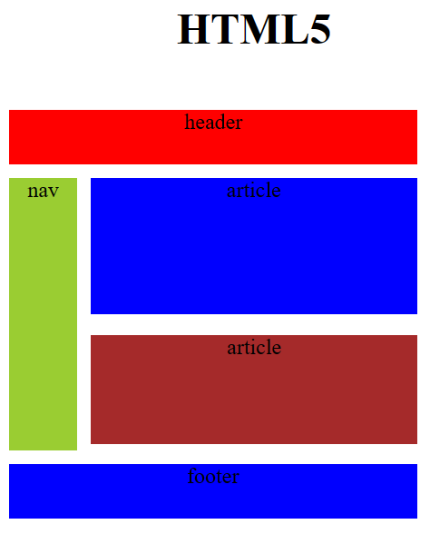

(Q) Canvas and SVG tags.

A.

|  |  |
| --- | --- |
| Canvas | SVG |
| Resolution dependent | Resolution independent |
| No support for event handlers | Support for event handlers |
| Poor text rendering capabilities | Best suited for applications with large rendering areas (Google Maps) |
| You can save the resulting image as .png or .jpg | Slow rendering if complex |
| Well suited for graphics- intensive games | No suited for game applications |
| Vector based (composed of shapes) | Raster based (composed of pixel) |
| Modified through script and CSS | Modified through script only |

SVG Input:

<!DOCTYPE html>

<html lang="en">

<head>

    <meta charset="UTF-8">

    <meta name="viewport" content="width=device-width, initial-scale=1.0">

    <title>Document</title>

    <style>

        #xyz{

            position: relative;

            left: 50%;

            -webkit-transform: translateX(-20%);

            -ms-transform: translateX(-20%);

            transform: translateX(-20%);

        }

    </style>

</head>

<body>

    <h1 align="center">SVG Circle</h1>

    <svg id="xyz" height="200">

        <circle id="greencircle" cx="60" cy="60" r="50" fill="red"></circle>

    </svg>

</body>

</html>

SVG output:



Canvas Input:

<!DOCTYPE html>

<html lang="en">

<head>

    <meta charset="UTF-8">

    <meta name="viewport" content="width=device-width, initial-scale=1.0">

    <title>Document</title>

</head>

<body>

    <h1>Canvas Square</h1>

    <canvas id="abc" width="100" height="100"

    style="border: 2px solid red;">

    </canvas>

    <script>

        var c=document.getElementById("abc");

        var ctx=c.getContext("2d");

        ctx.fillstyle="#7cce2b";

        ctx.fillRect(0,0,100,100);

    </script>

</body>

</html>

Canvas Output:

